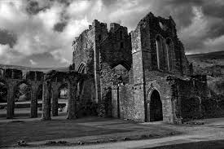
The 2016 ‘Icicles’ challenge
Saturday 27th – Sunday 28th February 2016

What is it?
A 2 day, 180 mile winter blast in the Black Mountains, South Wales for classic geared scooters.
So, At last it’s time for us to kick off the New Year’s riding season with our annual winter beer camp, the ’Icicles’ challenge. This year we will be heading to Llanthony Abbey in the Black Mountains. The campsite is known to us from the Circuit of Wales tour a few years back and provides a particularly excellent public house close by, who in turn serves up a mean Fish pie.
Irrespective of the weather we will take in some of the area’s best B-road action on both the Saturday and Sunday so dress warm and dry, service your bike and let those air pressures down a tadge – it could snow again…
The event and route has been designed to:
- Give an opportunity for us to embrace a little riding hardship and the winter’s worse weather extremes.
- Traverse some great roads with a good chance that there will be absolutely no one else on them.
- Test your new survival camp gear properly.
- Mean you will need lots of alcohol to keep warm and regret it at 05:00am
- Be bloody hilarious.

What do you need to partake and why?
- A sense of humour and adventure – so necessary.
- An assured riding ability. The roads will be wet, slippery, steep and uneven at times so a confidence in your own riding ability is essential. You have been warned.
- Good 4 season (or equivalent multi-layer) sleeping gear and tent. It was -7’c last year and revealed gaps in insulation very quickly.
- A classic geared Scooters (no Auto’s). It is a challenge for your steed as well as you and your bones….

The Route
Something a little different…...
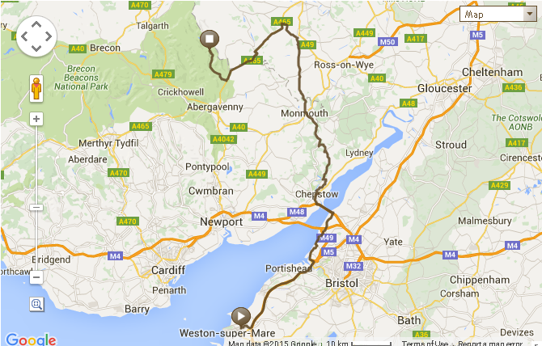
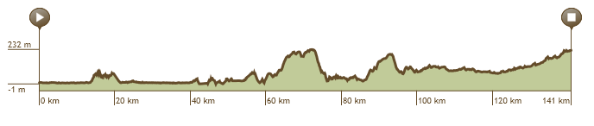

Route Highlights
The great run up to St Briavel’s castle on the edge of the wye Valley followed by the amazing hairpin drop to the River. A quick bacon bap stop at the Railway station and then push on for Monmouth and the cracking and aptly named Llan Cloudy ‘B’ road to Pandy. We could take the forest road through to the dam for a quick peep and time is on our side. Else it will be straight up the valley road to Llanthony Priory and home for the evening. Long grass and Public toilets await but a pub to die for nestles within staggering distance.

The Itinerary

Day | Location / Stop | Time | Comments
Sat 27th | Brent Knoll Garage – A38 | 08:45 | leave
 | Weston Super Mare - Costas | 09:30 | Fag stop and collect peeps
 | Aust Services | 10:30 | Petrol and Lunch
 | St Briavels | 11:00 | Castle and fag stop
 | Wye Valley Railway | 11:30 | Breakfast
 | Monmouth | 12:30 | Fag and fuel stop
 | LlanCloudy | 13:30 | Shiver and stamp feet
 | Pandy | 14:00
 | Llanthony | 15:00 | Camp spot and food.
Sun 28th | Break camp | 09:00
 | Abergavenny | 09:30 | Fuel stop
 | Iron horse café | 10:00 | Food, Fags and Fanny.
 | Chepstow | 11:30 | Fuel stop and handshakes
 | Weston Super Mare | 13:00 | Drop and handshakes
 | Brent Knoll | 13:30 | Final wave

Campsite Locations
Llanthony Priory, Black Mountains, Wales.
